Solution:

By superposition theorem, we could separate the respones from V1 and V2,

By setting V2 to zero (V1 is in close circuit), the only functioning source is V1 and we could get,

$$R= 24+ \frac{12*6}{12+6}=28 Ω$$

The voltage over the 12Ω resistor is

$v_{1}=6-24* \frac{6}{R}= 0.857 V$

By setting V1 to zero (V2 is in close circuit), the only functioning source is V2 and we could get,

$$R'= 6+ \frac{12*24}{12+24}=14 Ω$$

$v_{2}=12-6* \frac{12}{R^{'}}=6.857V$

$$v=v1+v2=0.857+6.857 V=7.714 V ≈7.71 V$$

Also, we could do the simulation by multism and protues. The equal answer could be got as shown down below.

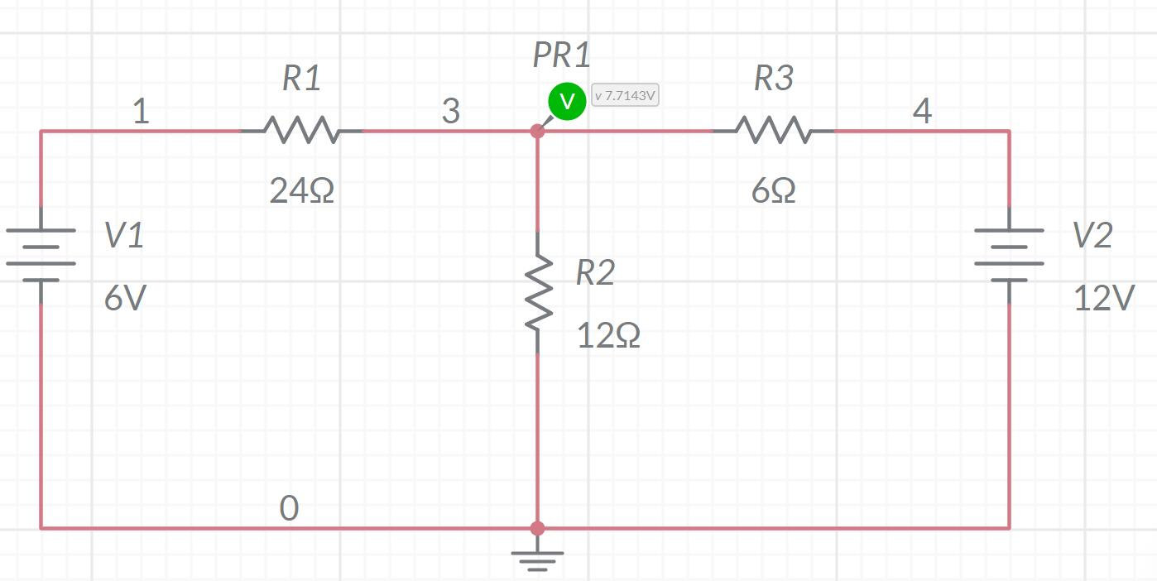

Figure 1 simulation result by multisim live

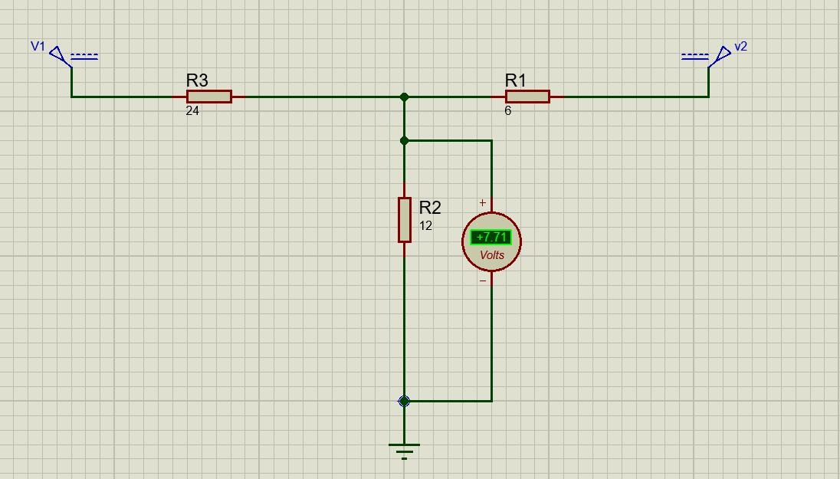

Figure 2 simulation result by protues

Note: The power source in protues should choose ideal source. The module of battery contain certain internal resistance.